Project Planning Phase
Project Planning Template (Product Backlog, Sprint Planning, Stories, Story points)

Date | 26 June 2026
Team ID
Project Name | UCAB – MERN Stack Cab Booking System
Maximum Marks | 5 Marks

Product Backlog, Sprint Schedule, and Estimation (4 Marks)
Sprint | Functional Requirement (Epic) | User Story Number | User Story / Task | Story Points | Priority | Team Members
Sprint-1 | Registration | USN-1 | As a user, I can register for the application by entering my name, email, and password. | 2 | High
Sprint-1 | Login | USN-2 | As a user, I can log into the application using my registered email and password. | 1 | High
Sprint-1 | View Cars | USN-3 | As a user, I can view the list of available cars along with their details. | 2 | High
Sprint-1 | Admin Login | USN-8 | As an admin, I can log in with my admin credentials. | 1 | High
Sprint-2 | Search Cars | USN-4 | As a user, I can search or filter cars based on my preference. | 3 | Medium
Sprint-2 | Book a Cab | USN-5 | As a user, I can select an available car and book a ride. | 5 | High
Sprint-3 | Booking History | USN-6 | As a user, I can view my past and current bookings. | 2 | Medium
Sprint-3 | Manage Cars | USN-10 | As an admin, I can add, edit, or delete cars and upload car images. | 5 | High
Sprint-3 | Manage Users | USN-11 | As an admin, I can view and manage all registered users. | 3 | Medium
Sprint-4 | Logout | USN-7 | As a user, I can log out of the application securely. | 1 | Low
Sprint-4 | Dashboard | USN-9 | As an admin, I can view statistics and charts on the dashboard. | 3 | Medium
Sprint-4 | Manage Bookings | USN-12 | As an admin, I can view all bookings made by users. | 3 | High

Project Tracker, Velocity & Burndown Chart: (4 Marks)
Sprint | Total Story Points | Duration | Sprint Start Date | Sprint End Date (Planned) | Story Points Completed (as on Planned End Date) | Sprint Release Date (Actual)
Sprint-1 | 6 | 6 Days | 03 Mar 2025 | 08 Mar 2025 | 20 | 2 June 2026
Sprint-2 | 8 | 6 Days | 10 Mar 2025 | 15 Mar 2025 | 20 | 4 June 2026
Sprint-3 | 10 | 6 Days | 17 Mar 2025 | 22 Mar 2025 | 20 | 6 June 2026
Sprint-4 | 7 | 6 Days | 24 Mar 2025 | 29 Mar 2025 | 20 | 8 June 2026

Velocity:
Imagine we have a 10-day sprint duration, and the velocity of the team is 20 (points per sprint). Let’s calculate the team’s average velocity (AV) per iteration unit (story points per day)
AV = Velocity per sprint / Sprint duration = 20 / 10 = 2 story points per day
For the UCAB project itself: Sprint-1 delivered 6 story points over its 6-day duration, giving an actual average velocity of 6 / 6 = 1 story point per day for that sprint.


Burndown Chart:
A burn down chart is a graphical representation of work left to do versus time. It is often used in agile software development methodologies such as Scrum. However, burn down charts can be applied to any project containing measurable progress over time.

UCAB – Project Burndown Chart:
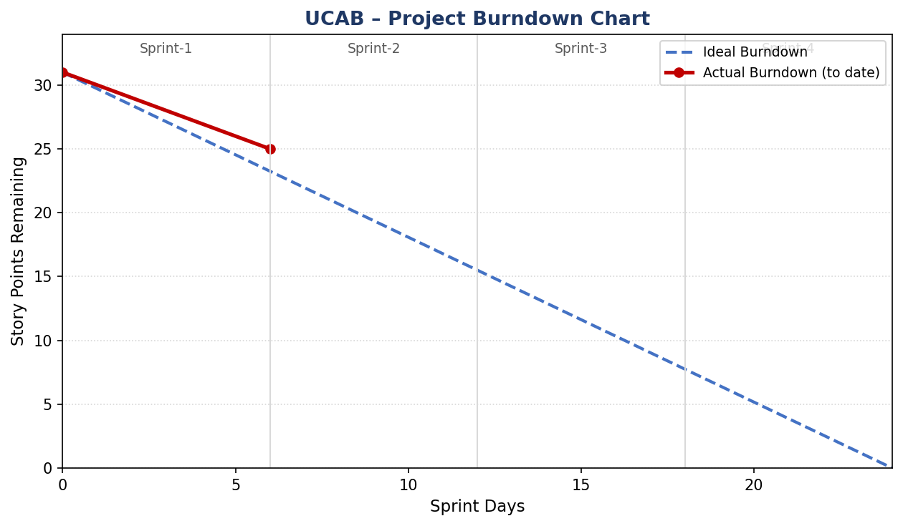
Figure: UCAB burndown across 4 planned sprints (31 total story points). Sprint-1 is complete (6/6 points); Sprints 2-4 are planned.

